QUESTION 1

Object-oriented programming (OOP) is a programming language model in which programs are organized around data, or objects, rather than functions and logic. An object can be defined as a data field that has unique attributes and behavior. Examples of an object can range from physical entities, such as a human being that is described by properties like name and address, down to small computer programs, such as widgets

QUESTION 2

* It provides a clear ***modular structure*** for programs which makes it good for defining abstract datatypes in which implementation details are hidden
* Objects can also be ***reused*** within an across applications. The reuse of software also lowers the cost of development. More effort is put into the object-oriented analysis and design, which lowers the overall cost of development.
* It makes software***easier to maintain.*** Since the design is modular, part of the system can be updated in case of issues without a need to make large-scale changes
* Reuse also enables ***faster development***. Object-oriented programming languages come with rich libraries of objects, and code developed during projects is also reusable in future projects.
* It provides a good framework for code libraries where the supplied software components can be ***easily adapted and modified by the programmer***. This is particularly useful for developing graphical user interfaces.

**QUESTION 3**

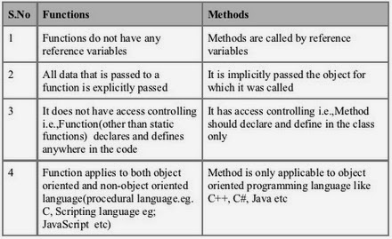

QUESTION 4

**Classes and Objects** are basic concepts of **Object** Oriented Programming which revolve around the real life entities. **Class**. A **class** is a user defined blueprint or prototype from which **objects** are created. It represents the set of properties or methods that are common to all **objects** of one type.

**Attribute** (computing) , In computing, an **attribute** is a specification that defines a property of an **object**, element, or file. It may also refer to or set the specific value for a given instance of such. For clarity, **attributes** should more correctly be considered metadata.